Brookhouse, Matthew, Dr (from Linked In)
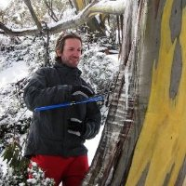

B.Sc. (Forestry) ANU 1997. Completed PhD in 2008.
Dendrochronologist DSE, Victoria 1997 – 2003. Developed and implement inventory as well as growth and yield measurement and analysis systems. Lecturer ANU 2009 –2011. Convened first-year course "Research Methods in Environment and Society" and later-year course "Quantitative Environmental Research Methods". Postdoctoral Research Fellow Australian National University 2012 – . Research position aimed improving understanding tree age-/size- related variations in water use in regrowth eucalypt forests. His research has attracted several awards including the Maxwell Jacobs Prize (2006), a Department of Agriculture, Forestry and Fisheries/Bureau of Rural Sciences Science and Innovation Award (2007) and an ANU Endowment for Excellence (2010).

